**Project 1**

**Building a CICD Pipeline for a Retail company**

We need to develop a CICD pipeline to automate the software development, testing, package, deploy reducing the time to market of app and ensuring good quality service is experienced by end users. In this project we need to

1. Push the code to Github repository.
2. Create a continuous integration pipeline using Jenkins to compile, test and package the code present in Github.
3. Write Docker file to push the war file to tomcat server.
4. Integrate Docker with Ansible and write playbook.
5. Deploy artifacts to Kubernetes cluster.
6. Monitor resources using Grafana.

Pre-requisites

1. Java

2. Maven

3. Git

4. Jenkins

5. Docker

6. Ansible

7. Kubernetes

8. Grafana

9. Prometheus

Resources used

1. An AWS account
2. A Github account
3. MobaXterm / Putty
4. Git Bash setup
5. Source Code

Downloaded the zip and extracted the source code on the local machine.

Then used initialized Git and used Gitbash to create a local repository and pushed the source code.

<https://github.com/Rohan-Francis/ABCTechnologies>

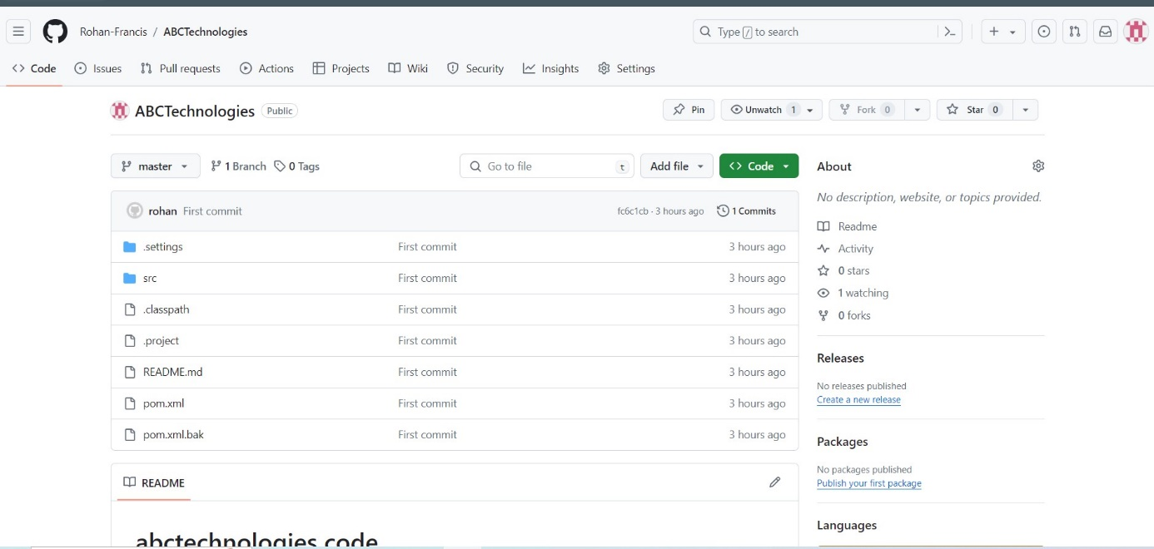

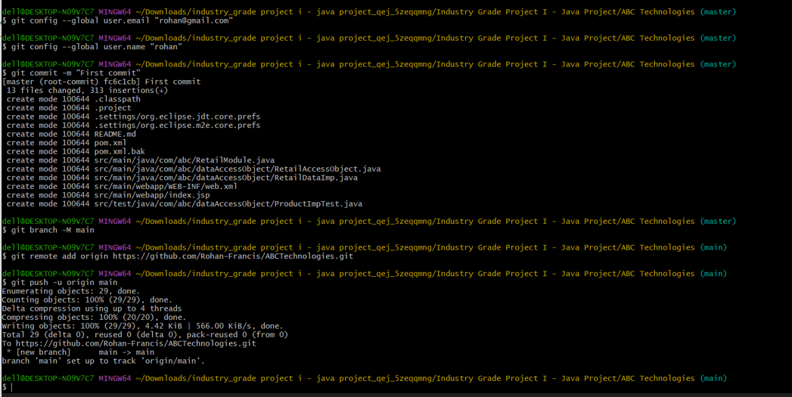

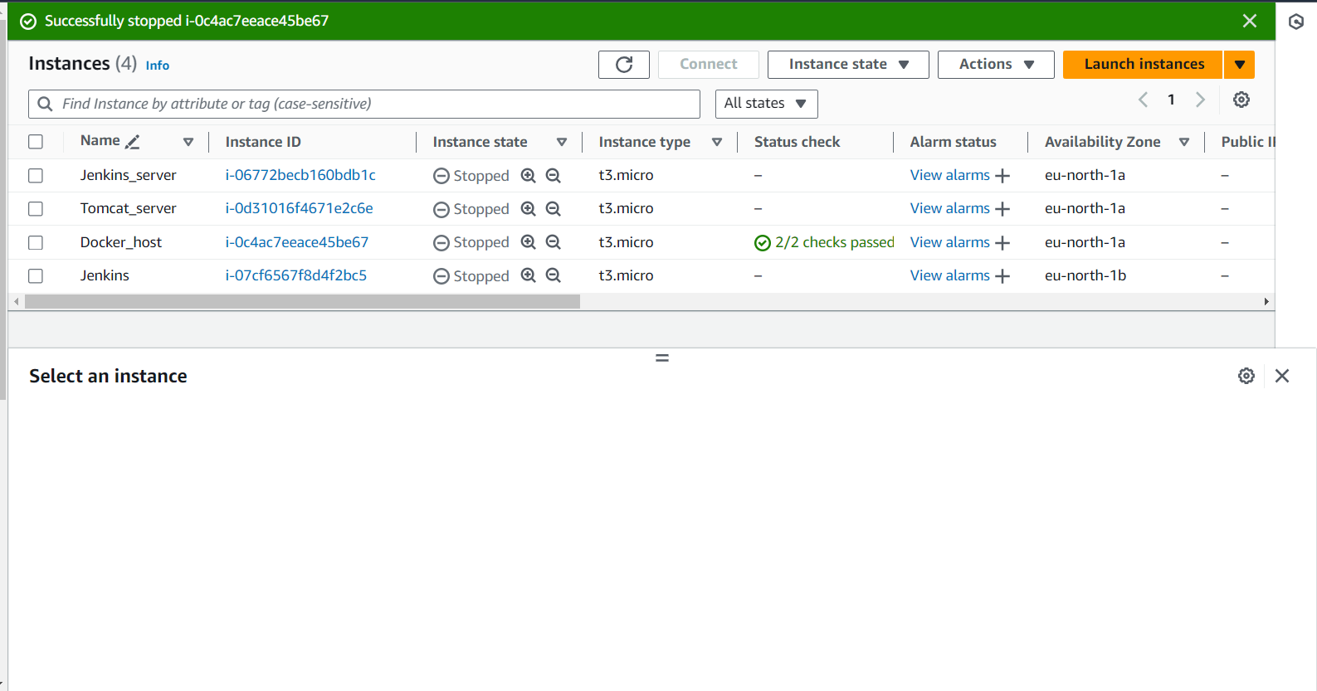

Then installed Jenkins using the below commands and configured Jenkins.

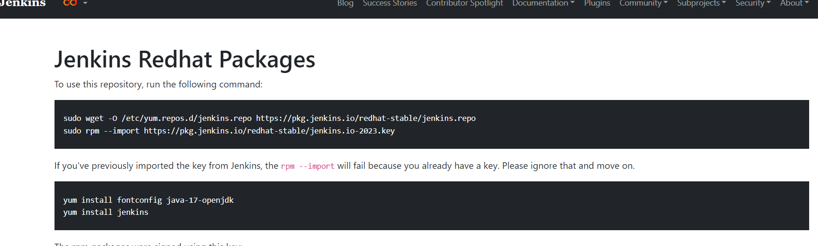

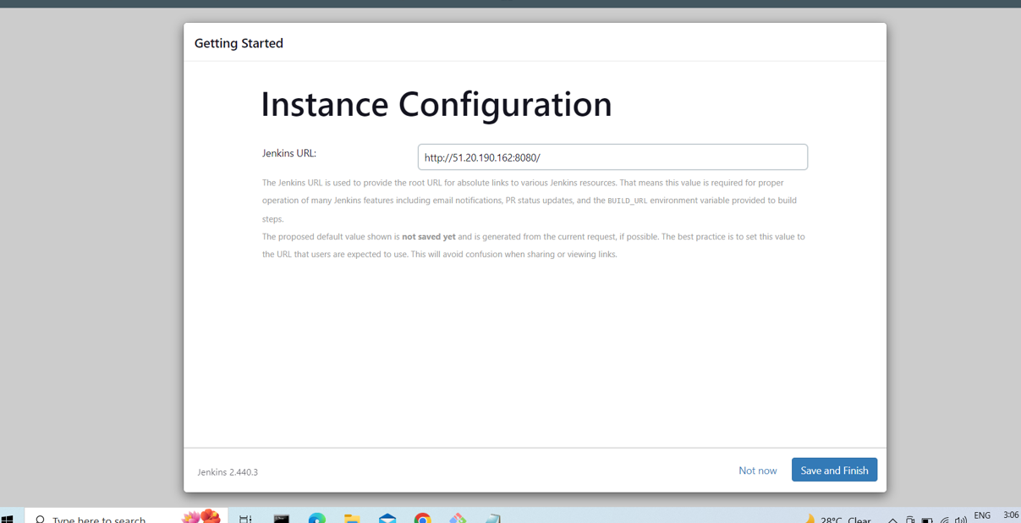

Wrote the pipeline code on Jenkins to compile, test and package the code.

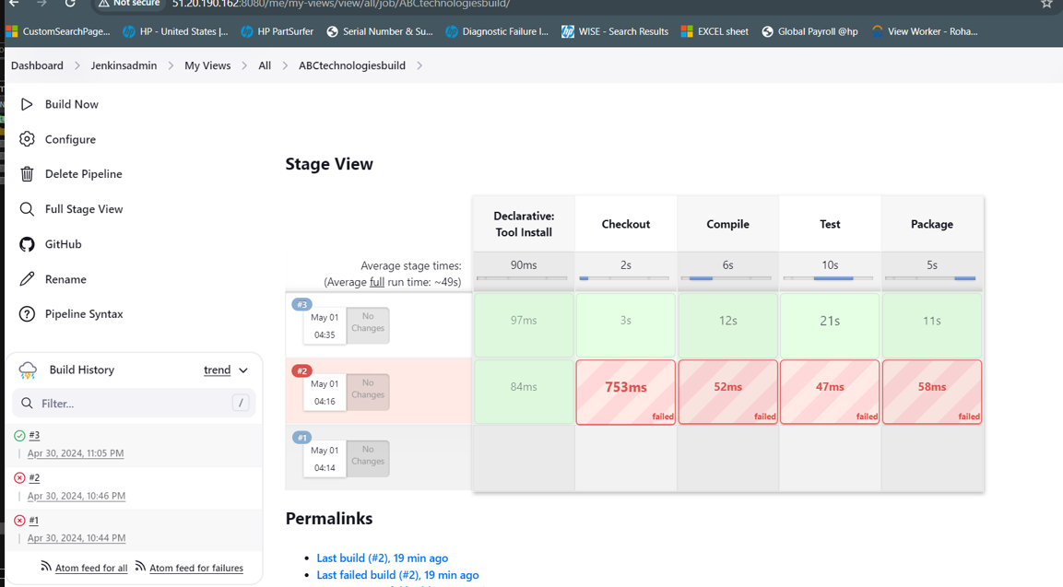

Now, using MobaXterm we install Java and Maven

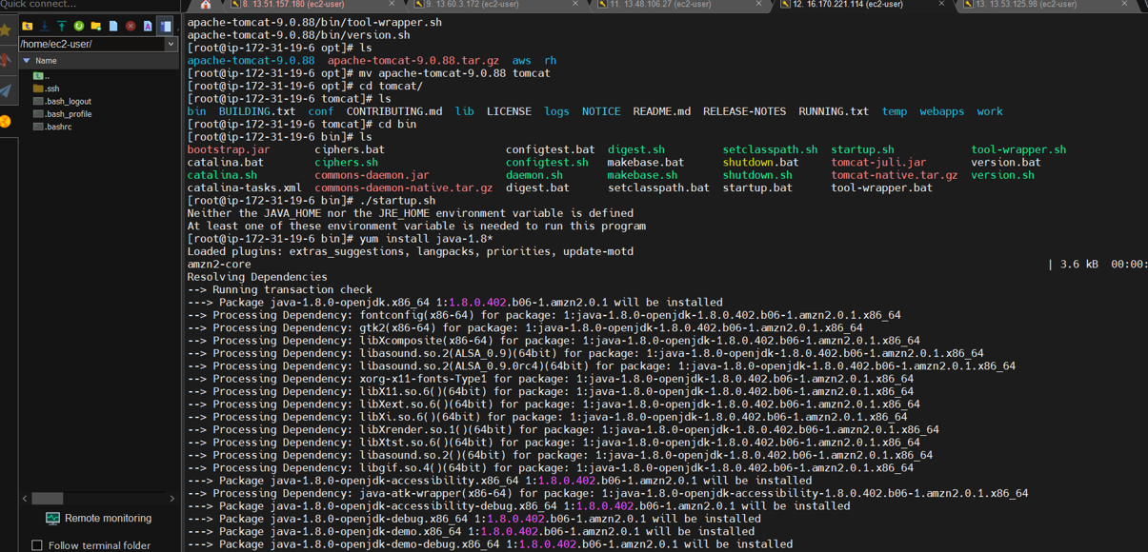

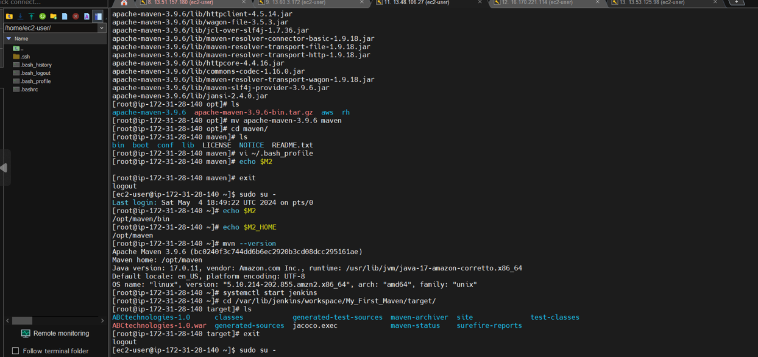

Now, we install Docker using the command

#yum install docker

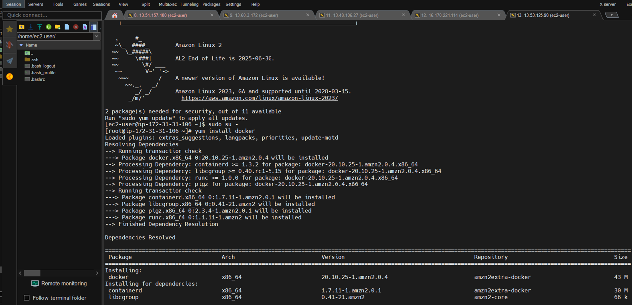

Give credentials to the Docker Hub

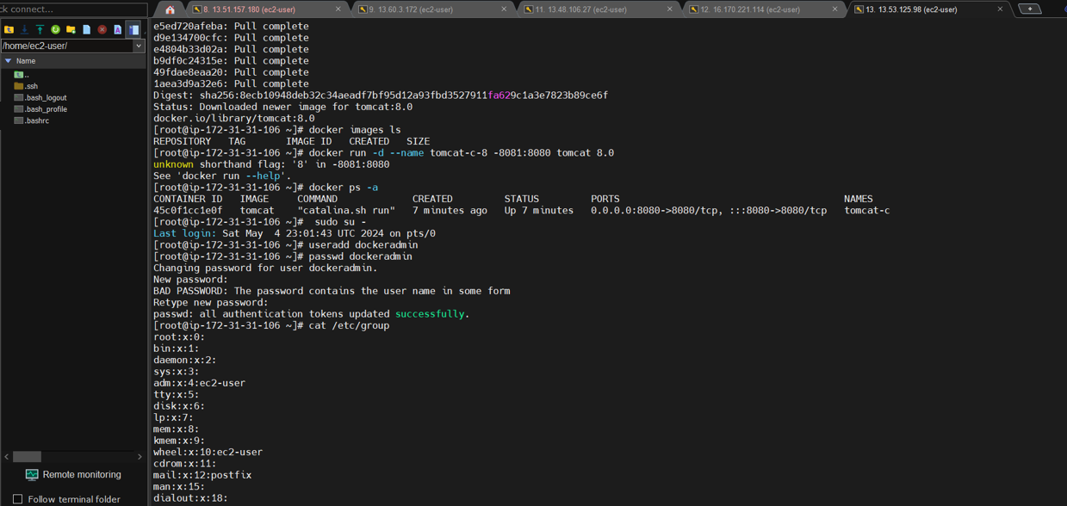

Now, we deployed docker in Jenkins

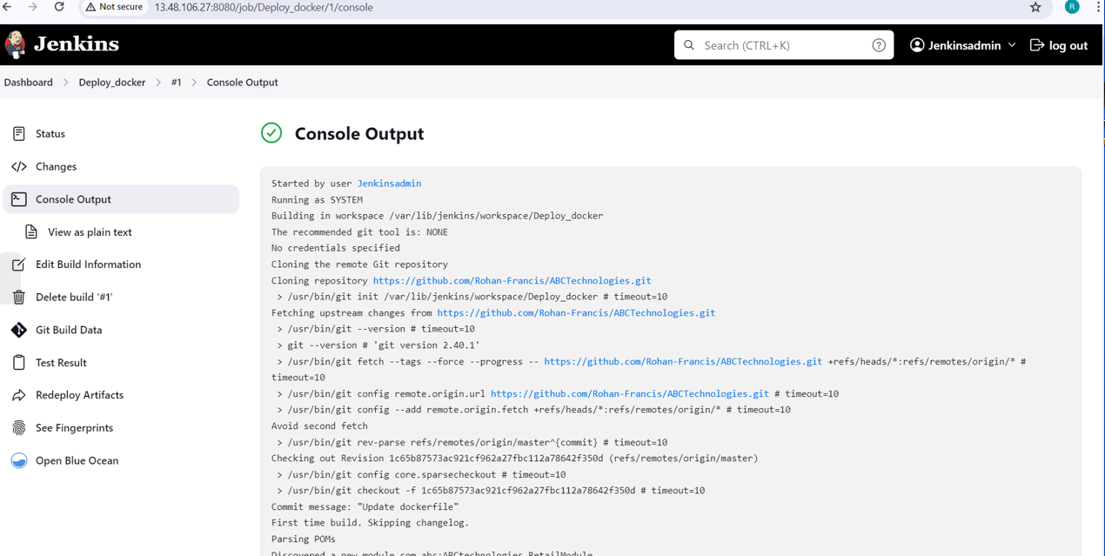

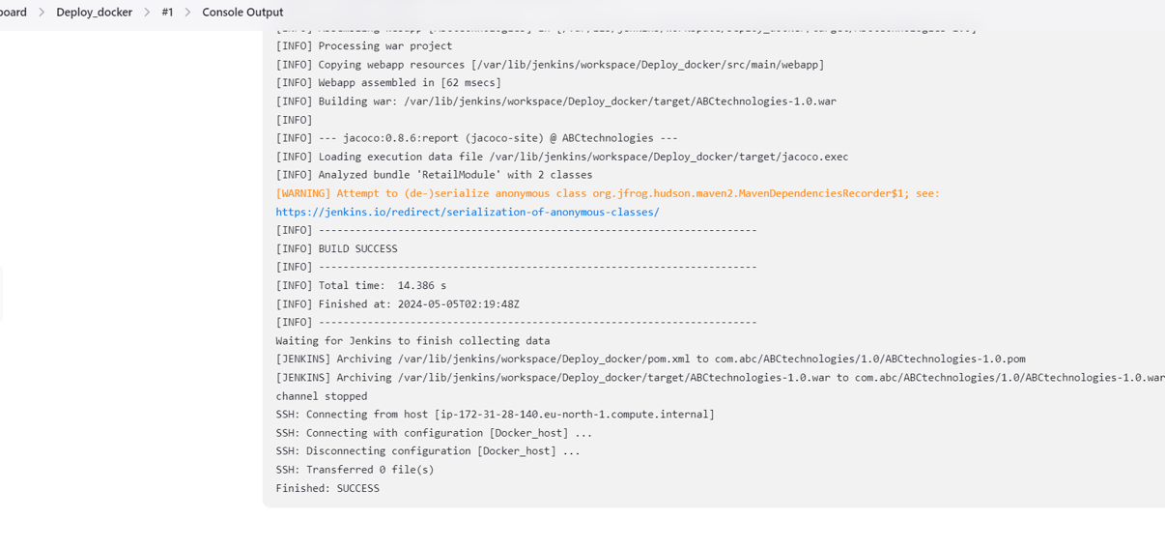

Then we build the Docker image

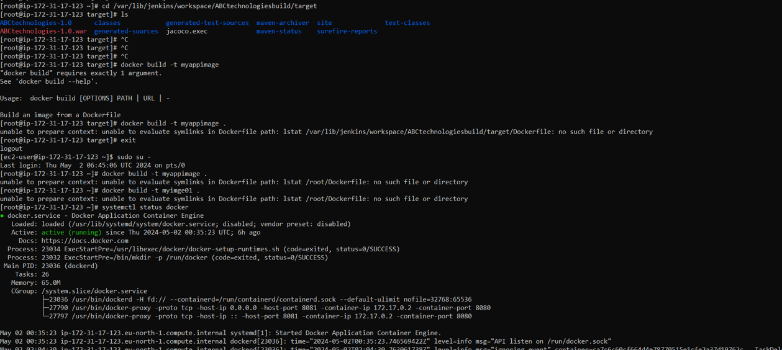

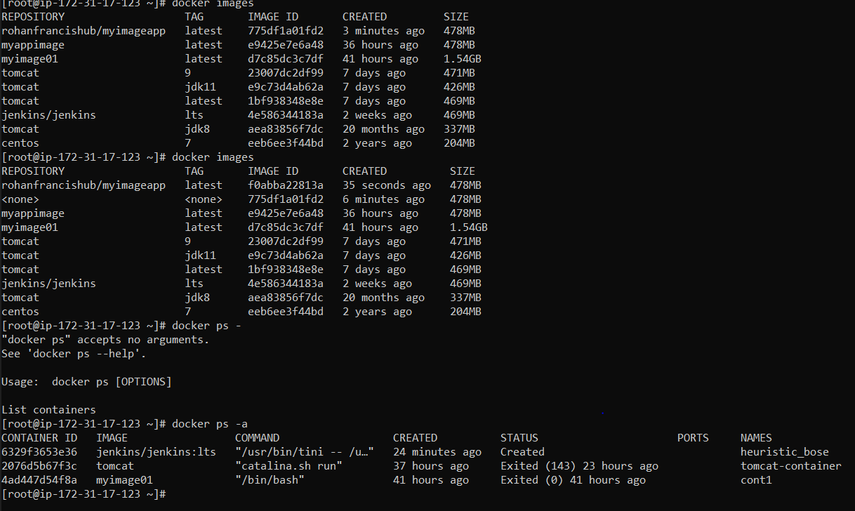

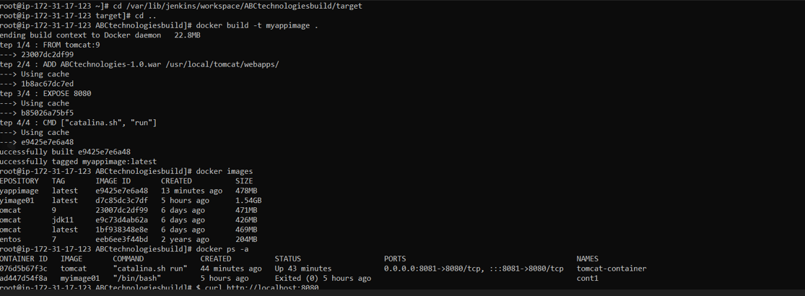

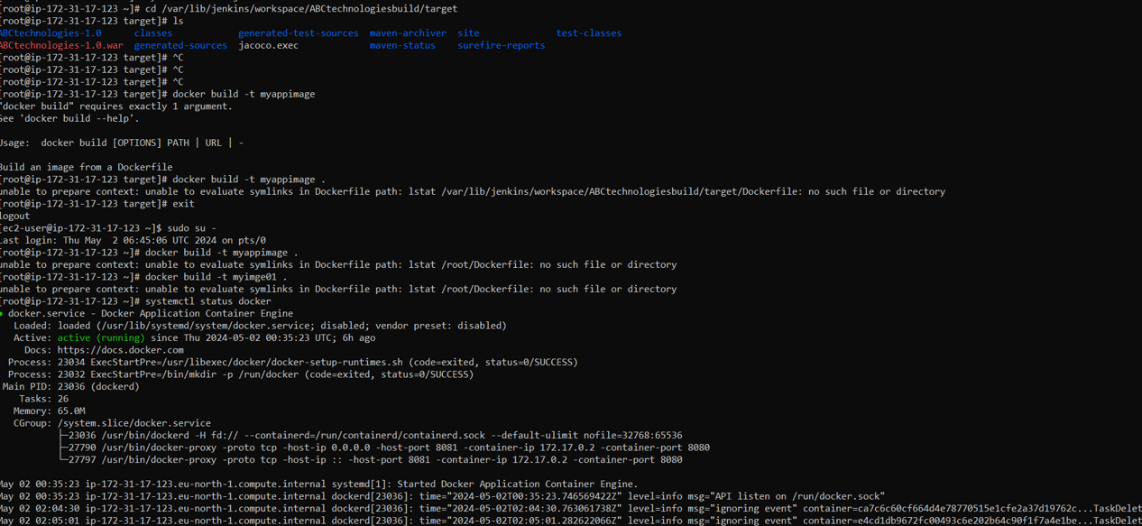

Set up the Docker Hub and you will find the Docker image

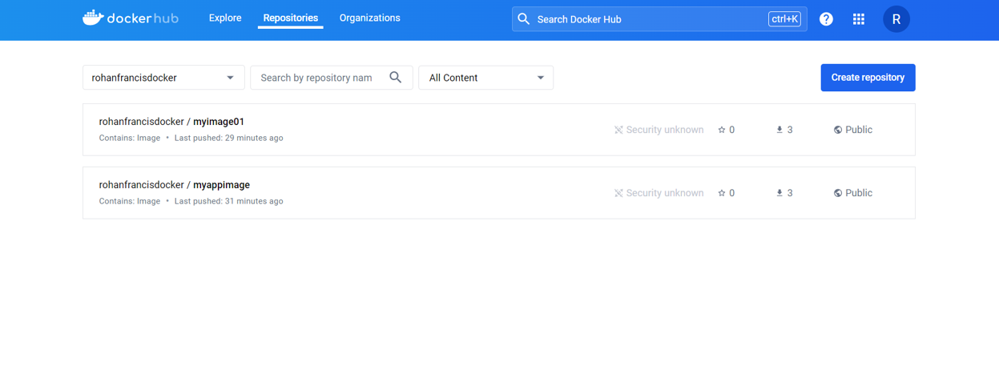

Credentials set up of Docker Hub in Jenkins

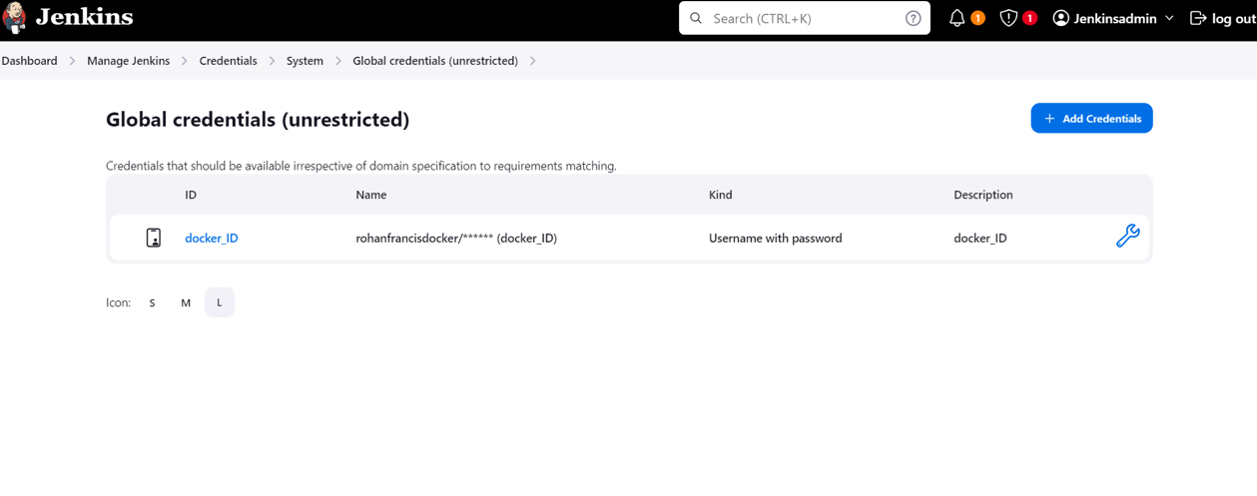

Pushing the image to Docker Hub using Jenkins

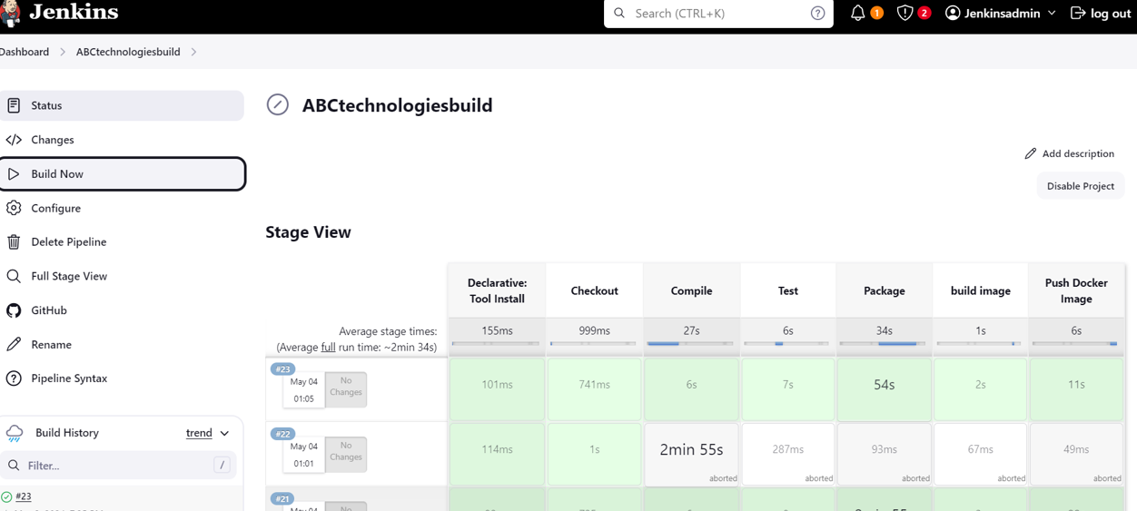

Setting up of Tomcat

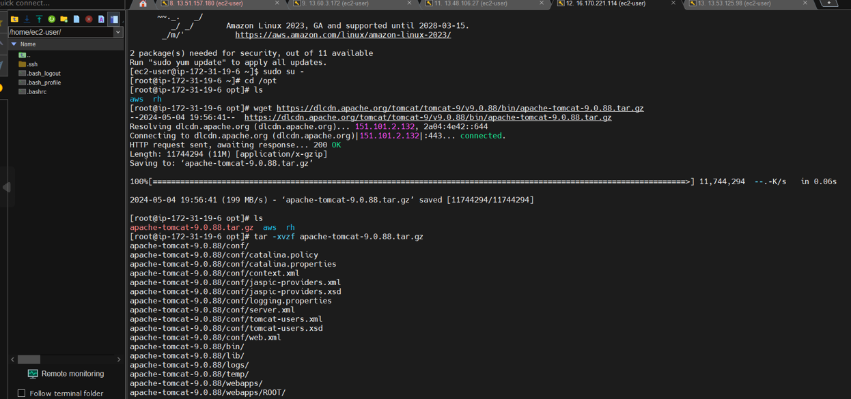

Changing the directory for Tomcat login

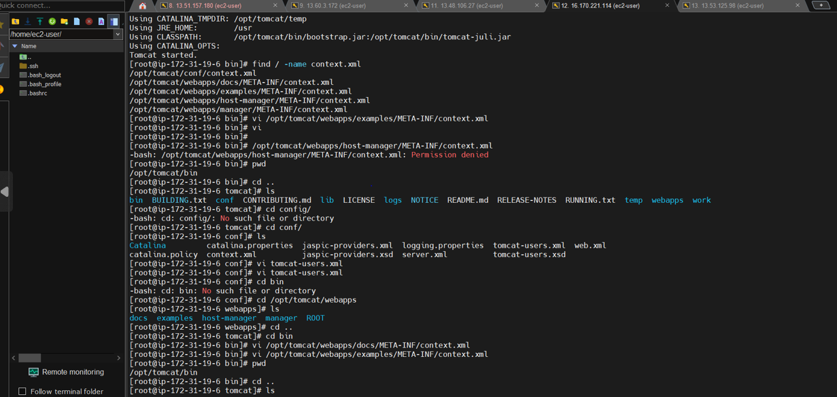

Using Docker with Tomcat

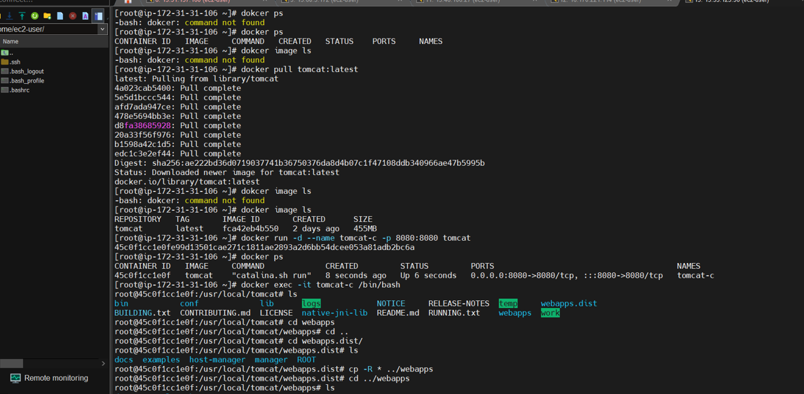

Tomcat login page

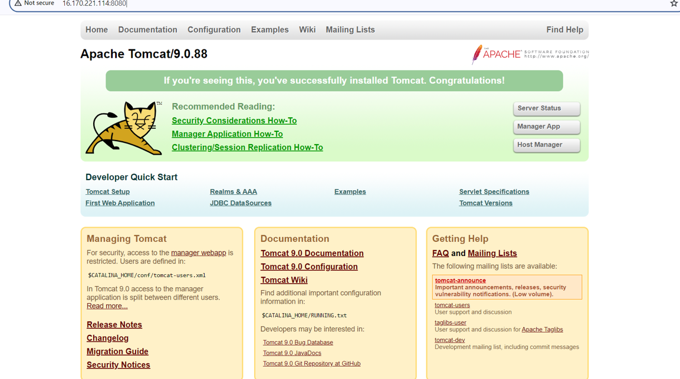

By using the below, we managed to change the roles for Tomcat login page

<role rolename="manager-gui"/>

<role rolename="manager-script"/>

<role rolename="manager-jmx"/>

<role rolename="manager-status"/>

<user username="admin" password="admin" roles="manager-gui, manager-script, manager-jmx, manager-status"/>

<user username="deployer" password="deployer" roles="manager-script"/>

<user username="tomcat" password="tomcat" roles="manager-gui"/>

</tomcat-users>

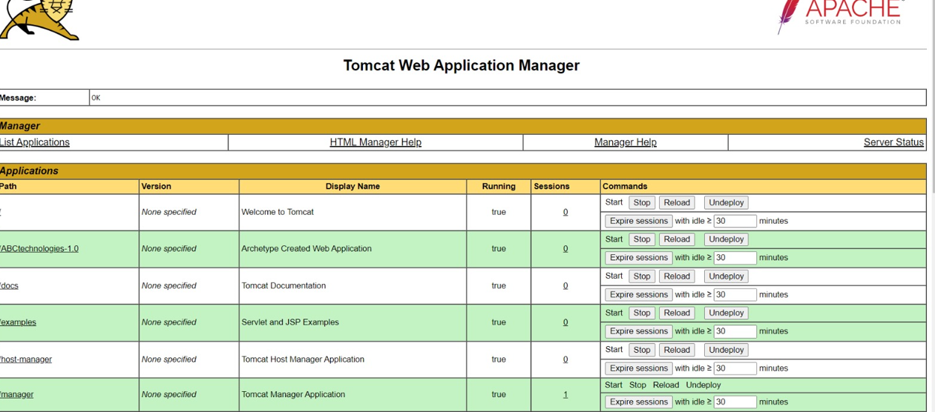



Now we go ahead and install Ansible

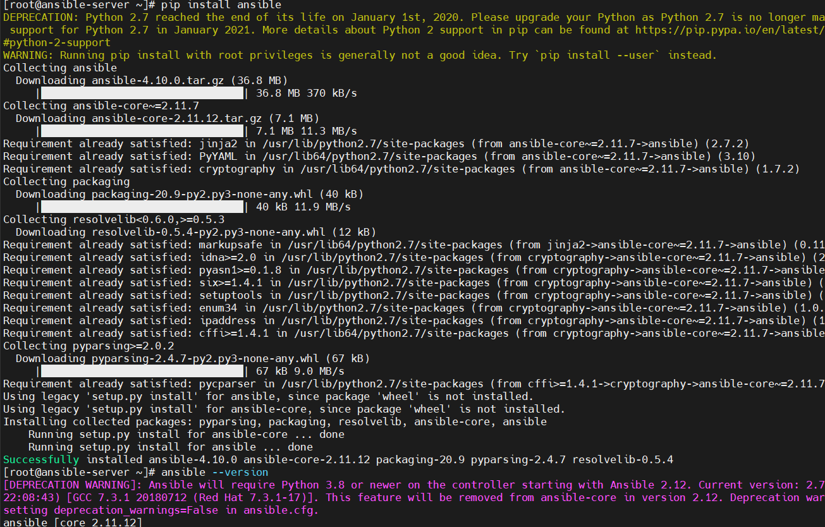

Then we install Python

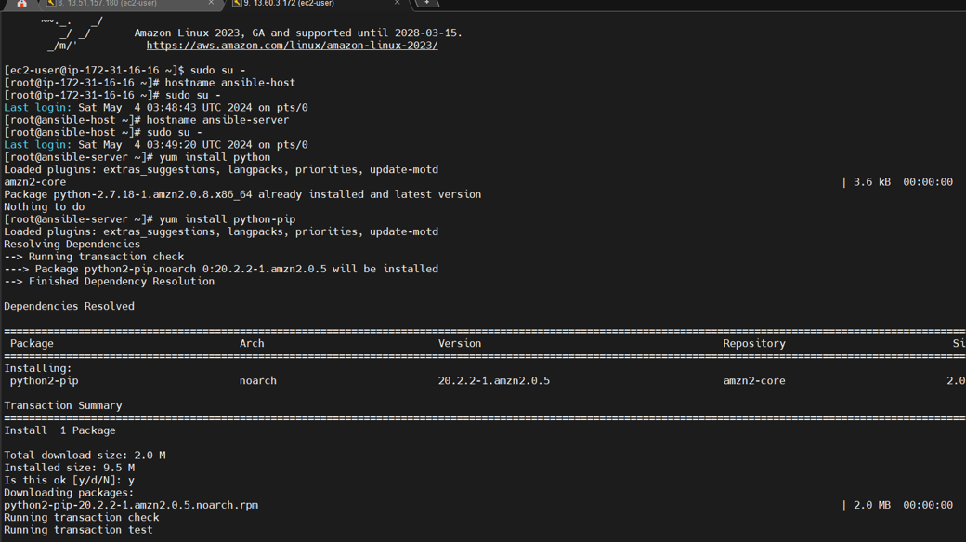

We now change the SSHD configuration

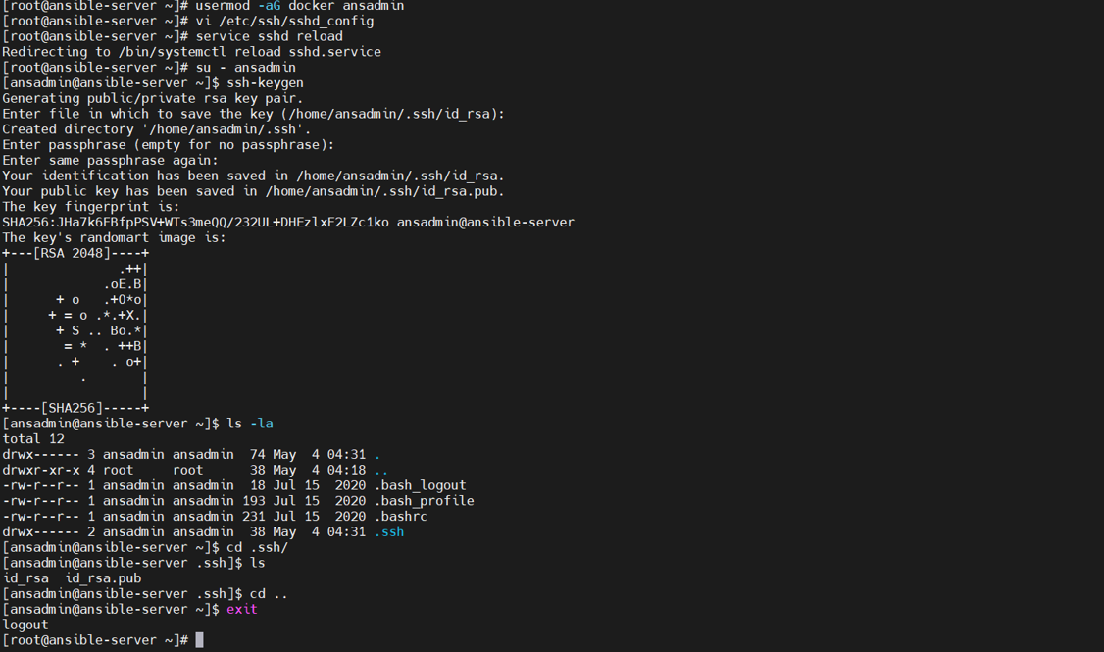

Then integrate Ansible with Docker

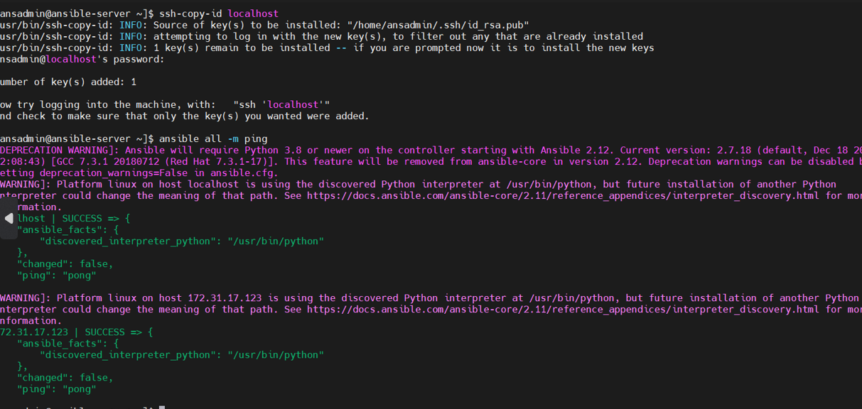

Now connect to Ansible terminal

sudo su -

useradd ansadmin

passwd ansadmin

vim /etc/ssh/sshd_config

( PasswordAuthentication yes )

visudo

( ansadmin ALL=(ALL) NOPASSWD: ALL )

systemctl restart sshd

sudo su - ansadmin

ssh-keygen

Write Ansible playbook which creates a container from the Docker image

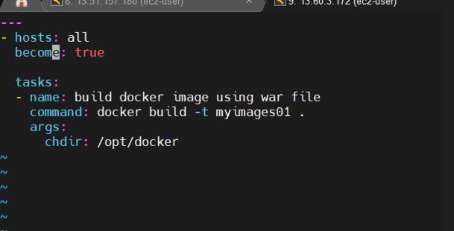

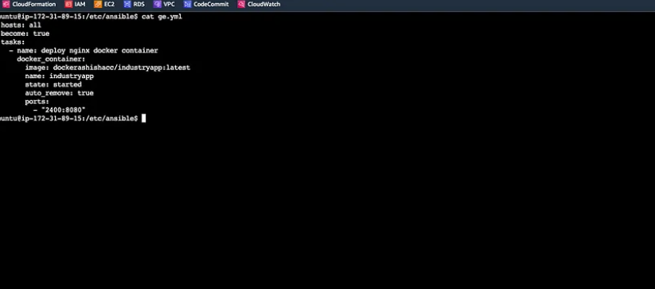

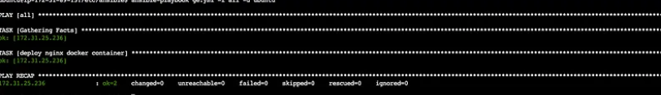

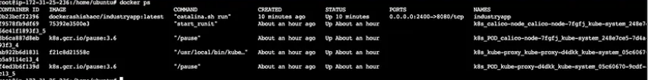



Then install Kubernetes

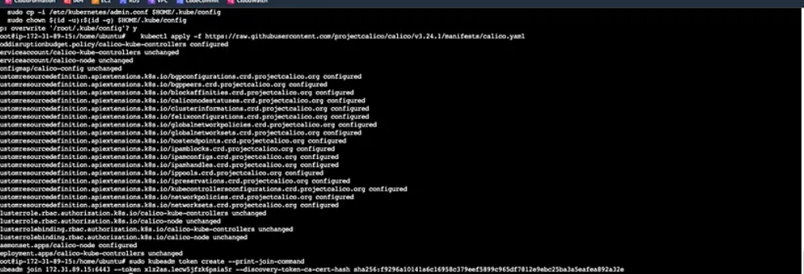

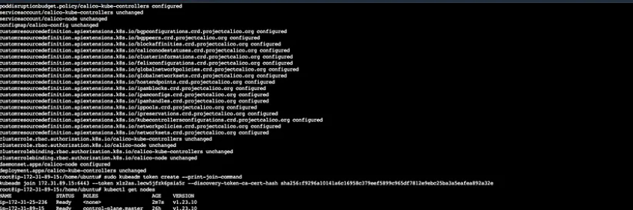

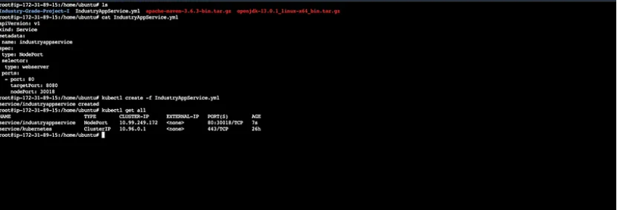

Deployment manifest is below

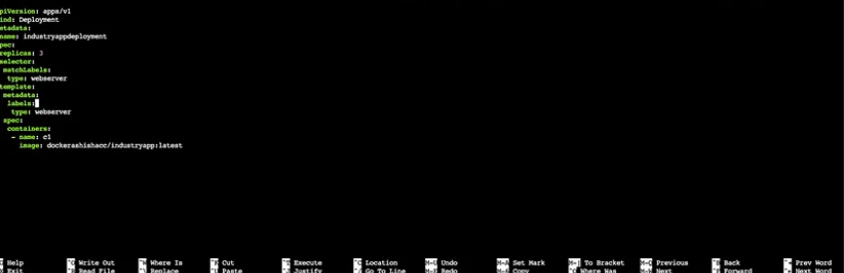

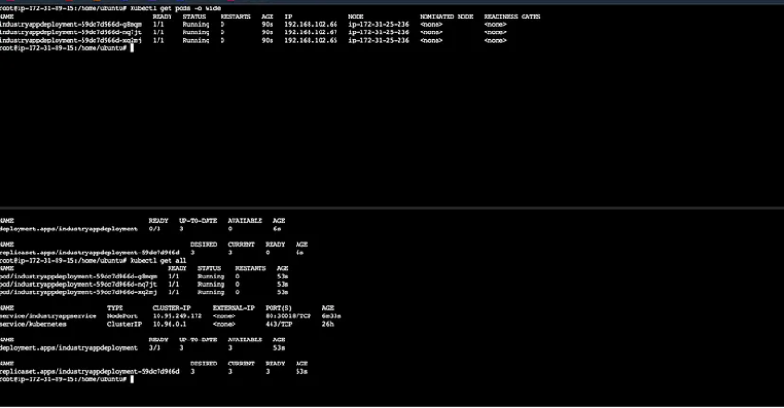

Successfully created pods, deployment and service using Kubernetes.

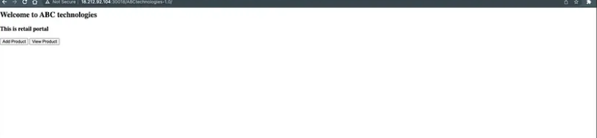

Integrating with Jenkins

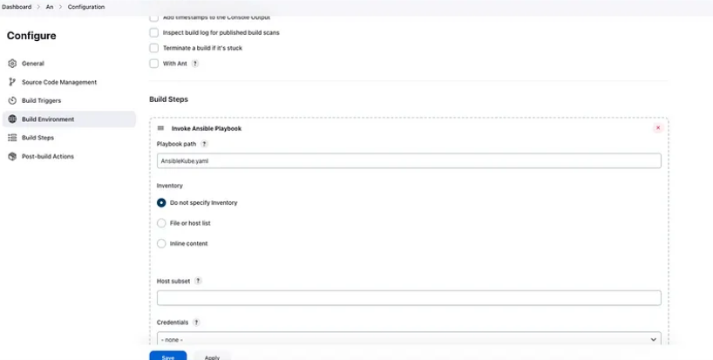

Ansible playbook is executed successfully

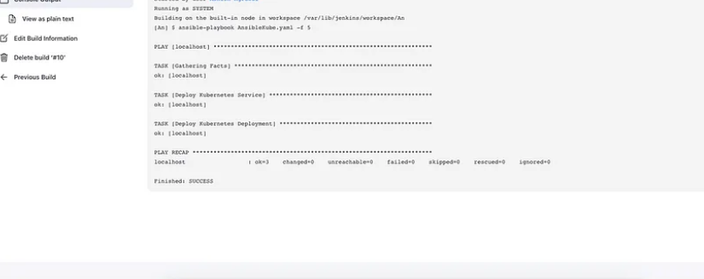

File that was executed with deployment and service

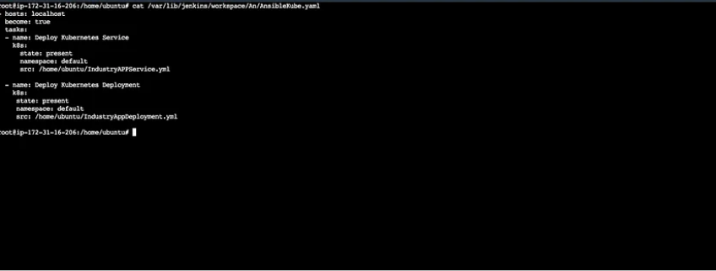

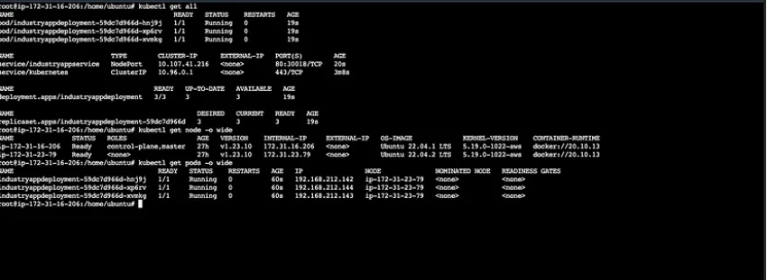

Using Prometheus and Grafana to monitor the utilization

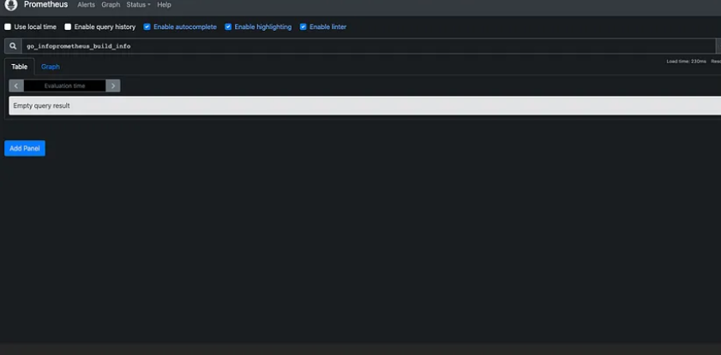

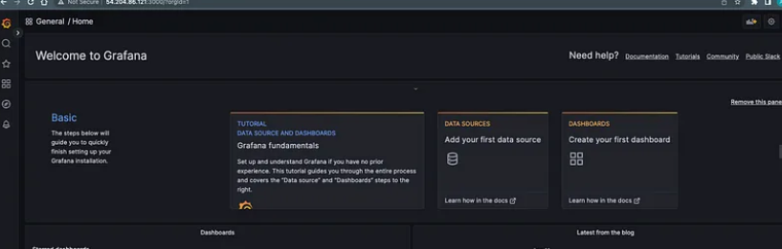

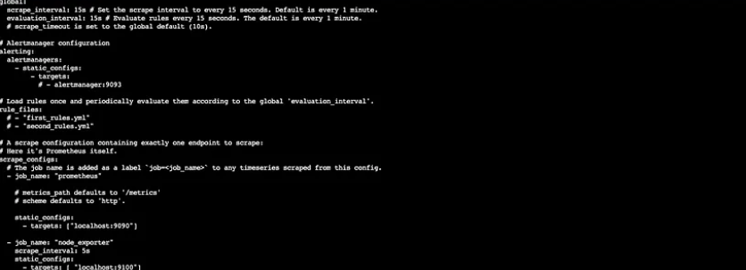

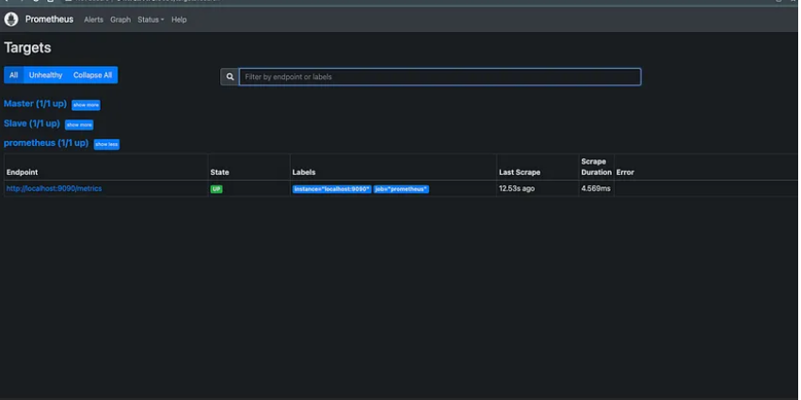

CPU utilization:

